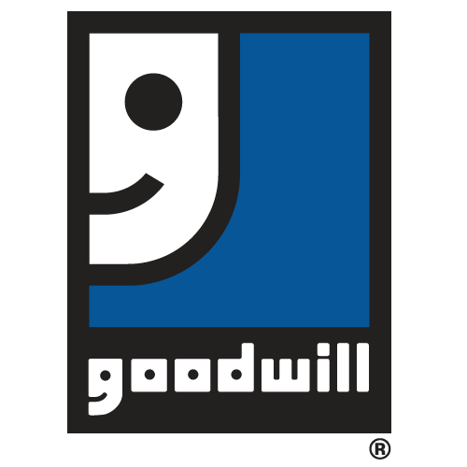
Our Commitment to You Regarding Your Privacy
Goodwill Industries of North Louisiana is committed to respecting the privacy of its financial and in-kind donors, whether the donation is made online, by mail or any other method. When you make a financial or in-kind donation, you can choose to provide your name and contact information. Financial donors provide standard payment information including, in many circumstances, credit card data. We protect your information in a variety of ways, as described below.
We use industry standard safeguards to protect your information. Many donors use credit cards for donations. We protect the security of credit card transactions using a number of measures such as encryption, access controls, network firewalls, and physical security. These measures make it extremely difficult for anyone to intercept the credit card information you send to us. When we work with other companies to process credit card transactions, those companies also use encryption and other appropriate security measures.
We do not sell, share or trade our donors’ personally identifiable information with any other entity. In addition, we will not send mailings to our donors on behalf of other organizations, unless a donor has given us specific permission to do so. Our Goodwill staff are bound by strict confidentiality rules and only a limited number of our staff have access to donor data.
For more information on our privacy policy or if you have further questions, please contact Goodwill’s Administrative offices at 318-868-4701.

